Vulnerabilities:
Important Case Studies
https://bartoli.inginf.units.it 1
Role of Vulnerabilities in MITRE ATT&CK
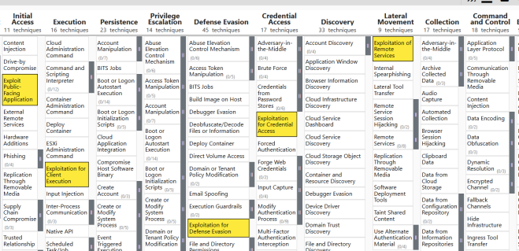
❑ Almost every tactic
❑ Fundamental tool for attackers
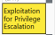
(not to be overestimated)
08/11/2025 https://bartoli.inginf.units.it 2
Our path
❑ We will look at specific examples
❑ Tiny little bug in software → Catastrophe
❑ Discussion of implications for cybersecurity and testing ❑ Much broader discussion later
08/11/2025 https://bartoli.inginf.units.it 3
PaloAlto Networks
Global Protect (April 2024)
08/11/2025 https://bartoli.inginf.units.it 4
PaloAlto Networks
Global Protect (I)
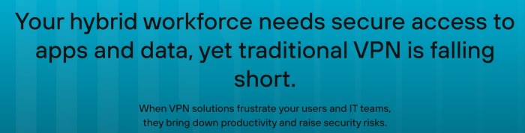08/11/2025 https://bartoli.inginf.units.it 5
PaloAlto Networks
Global Protect (II)
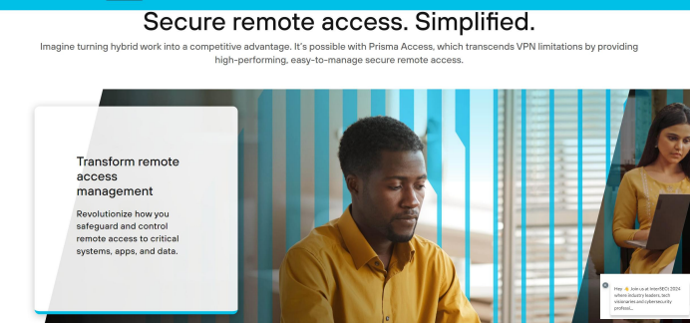08/11/2025 https://bartoli.inginf.units.it 6
Tiny little bug
❑ Web application does not check that Cookie values have the expected syntactic structure
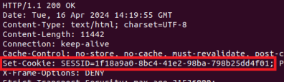

❑ Well, what impact this tiny little problem
could possibly have?
08/11/2025 https://bartoli.inginf.units.it 7
Oh my...
❑ Unauthenticated attacker may execute arbitrary code with root privileges on the firewall
08/11/2025 https://bartoli.inginf.units.it 8
How the appliance works (reverse engineered)
08/11/2025 https://bartoli.inginf.units.it 9
Session State Management ❑ Session State of session ID is stored in file named /tmp/sslvpn/session_ID
08/11/2025 https://bartoli.inginf.units.it 10
Telemetry data (I)
❑ Telemetry data ("what happened"):
❑ Stored in these directories (files of a certain format) /opt/panlogs/tmp/device_telemetry/hour /opt/panlogs/tmp/device_telemetry/day
❑ Sent every hour to a configuration-specified URL 08/11/2025 https://bartoli.inginf.units.it 11
Telemetry data (II)
❑ Sent every hour to a configuration-specified URL ❑ Periodic cron job
❑ File upload with curl command
08/11/2025 https://bartoli.inginf.units.it 12
curl command
within code (I)
...
curl_cmd = "/usr/bin/curl –v
–H \"Content-Type: application/octet-stream\" -X PUT \"%s\"
--data-binary @%s
--capath %s
--interface %s"\
%(signedUrl, fname, capath, source_ip_str)
...
pansys(curl_cmd, shell=True, timeout=250)
...
08/11/2025 https://bartoli.inginf.units.it 13
curl command
within code (II)
...
pansys(curl_cmd, shell=True, timeout=250) ...
// nested within several function invocations ...
p = subprocess.Popen(cmd,
stdout=subprocess.PIPE,
bufsize=1, shell=True,
stderr=subprocess.PIPE,
close_fds=close_fds,
universal_newlines=True)
...
Description of parameters by ChatGPT
https://chat.openai.com/share/f3fd3d41-8660-44e8-b3b7-46b0fe713d6f
08/11/2025 https://bartoli.inginf.units.it 14
Putting it all together
08/11/2025 https://bartoli.inginf.units.it 15
Arbitrary Empty File Creation ❑ Web application does not check that Cookie values
have the expected syntactic structure
+
❑ Session State of session ID is stored in file named
/tmp/sslvpn/session_ID
❑ Send HTTP Request with carefully structured cookie value will create an empty file with attacker-controlled name
Cookie: SESSID=test_data
08/11/2025 https://bartoli.inginf.units.it 16
Bad Practices (I)
1. Web application runs as root 2. ...
❑ Not necessarily wrong
❑ In this case essential for the exploit ❑ Not only for its impact
08/11/2025 https://bartoli.inginf.units.it 17
Directory Traversal
❑ Web application runs as root
+
❑ Send HTTP Request with carefully structured cookie value will create an empty file with attacker-controlled name
in any arbitrary attacker-chosen directory
Cookie: SESSID=./../../../hello_as_root
For some reason, with directory traversal the heading "session_" is not inserted in filename
08/11/2025 https://bartoli.inginf.units.it 18
What we have so far
❑ We can write an empty file of our choice in any directory
❑ We can write an empty file of our choice in telemetry directories
❑ curl will send an empty telemetry file of our choice to the configuration-specified URL
❑ Not useful (yet)
08/11/2025 https://bartoli.inginf.units.it 19
subprocess.Popen() (I)
// nested within several function invocations ...
p = subprocess.Popen(cmd,
stdout=subprocess.PIPE,
bufsize=1, shell=True,
stderr=subprocess.PIPE,
close_fds=close_fds,
universal_newlines=True)
...
08/11/2025 https://bartoli.inginf.units.it 20
subprocess.Popen() (II)
❑ cmd = "/usr/bin/curl -v … -X PUT …"
❑ subprocess.Popen(cmd,...,shell=False,...) ❑ cmd is a list of strings
❑ Spawns a shell that executes cmd[0]
(with cmd[1],cmd[2],… as parameters)
❑ This is the default
❑ subprocess.Popen(cmd,...,shell=True,...) ❑ cmd is a string
❑ Spawns a shell that executes cmd
08/11/2025 https://bartoli.inginf.units.it 21
Linux shell feature:
Backticks
2
1
echo "Today is `date`"
echo "Number of files: `ls | wc -l`"
❑ Command enclosed within backticks ❑ Bash behavior:
1. Execute that command first
2. Replace it with its output
3. Execute enclosing command
08/11/2025 https://bartoli.inginf.units.it 22
BOOM!
Cookie: SESSID=PATH_TO_TELEMETRY_DIR/aaa`command`
1. Cookie management will create file named aaa`command` in telemetry directory
2. Telemetry will invoke a shell for executing
curl ... -X PUT ... aaa`command`... 3. Shell will execute command and then curl
(as root!)
❑ Unauthenticated remote command injection
08/11/2025 https://bartoli.inginf.units.it 23
Bad Practices (II)
1. Web application runs as root
2. Executes a shell even though it needs to execute one single command
❑ Not necessarily wrong
❑ In this case they were essential for the exploit
08/11/2025 https://bartoli.inginf.units.it 24
DEFAULT
subprocess.Popen()
Cookie: SESSID=PATH_TO_TELEMETRY_DIR/aaa`command`
1. Cookie management will create file named aaa`command` in telemetry directory
2. Telemetry will execute
curl ... -X PUT ... aaa`command`... 3. curl will upload that (empty) file to the configuration URL
❑ Unauthenticated remote command injection
08/11/2025 https://bartoli.inginf.units.it 25
Never Forget
❑Web application does not check that Cookie values have the expected syntactic structure
+
❑Two bad practices
=
❑Unauthenticated Remote Command Execution (Pre-Auth RCE)
08/11/2025 https://bartoli.inginf.units.it 26
Understanding this vuln
❑ What is the exploit?
❑ What is the payload?
❑ What is the threat model for its exploitation?
❑ How difficult is exploit development? ❑ How difficult is injection?
❑ Can it be used for Initial Access? Which technique? ❑ For Execution?
❑ For Persistence?
08/11/2025 https://bartoli.inginf.units.it 27
Reasoning about detection
❑ How to detect injection attempts? ❑ ...how to block them?
❑ How to detect injections after the fact?
08/11/2025 https://bartoli.inginf.units.it 28
General Lessons about
vulnerabilities
08/11/2025 https://bartoli.inginf.units.it 29
You never know
1. Web application runs as root
2. Executes a shell even though it needs to execute one single command
❑Unsafe practices are unsafe. Period. ❑One cannot predict their reach
❑Avoid them as much as you can
08/11/2025 https://bartoli.inginf.units.it 30
Never ONE reason
❑Vulnerabilities never result from one single reason
❑They usually result from many different and seemingly unrelated reasons
08/11/2025 https://bartoli.inginf.units.it 31
NEVER trust input data
❑Never. Not even implicitly
❑Structure may not be what you expect ❑Values may not be what you expect
❑Much easier said than done
08/11/2025 https://bartoli.inginf.units.it 32
Testing (I)
❑More intensive / accurate testing might have discovered a bug
❑It would have not discovered this vulnerability automatically
08/11/2025 https://bartoli.inginf.units.it 33
Testing (II-a)
❑Do not expect to discover a vulnerability in your testing campaigns
❑You will usually observe only bugs
08/11/2025 https://bartoli.inginf.units.it 34
Testing (II-b)
❑ Bugs have to be categorized:
1. Not vulnerability
2. Hardly exploitable vulnerability
3. Exploitable vulnerability
❑ Categorization requires skills, time, manual work
❑ Never quickly dismiss a bug as "this is not a vulnerability" ❑ Never start crying whenever you discover a bug
08/11/2025 https://bartoli.inginf.units.it 35
Very deep question
❑You are testing your software product
❑Which inputs should you inject?
❑Those representative of normal usage
❑Wrong, either partially or in full
08/11/2025 https://bartoli.inginf.units.it 36
Cybersec is a different
(harder) game!
❑ Fridge design and development
❑ Requirement:
❑Operation with external temperature [-15,+40] °C
❑ You will not test with 200 °C
❑ You will not design it for tolerating 200 °C
08/11/2025 https://bartoli.inginf.units.it 37
Adversarial != Hostile
❑ Non-SW artifacts: Hostile environment:
❑ Inputs may be "extreme" and perhaps "uncommon"
❑ SW artifacts: Adversarial environment:
❑ Inputs actively and carefully selected to provoke undesired behavior
❑ "The worst possible input, at the worst possible time" 08/11/2025 https://bartoli.inginf.units.it 38
Keep in mind
❑ Non-SW engineers must cope with hostile environments
❑ SW engineers must cope with adversarial environments
❑ They play different games!
08/11/2025 https://bartoli.inginf.units.it 39
Another Interesting Example
08/11/2025 https://bartoli.inginf.units.it 40
A simple
network protocol (I)
Length of next field
someConst 6 012345 ...(2KB)...
sort of
echo
012345
08/11/2025 https://bartoli.inginf.units.it 41
A simple
network protocol (II)
❑ Request message:
1. Integer someConst (predefined constant) 2. Integer echo_length
3. Byte array with echo_length elements 4. Byte array with 2048 elements
❑ Field 3 cannot be longer than 1024 elements
❑ Response message:
1. Byte array in field 3 of request
08/11/2025 https://bartoli.inginf.units.it 42
Server Implementation Outline
#define LEN 4096
char respBuf[4096], reqBuf[4096];
...
// socket: create, listen, accept
// receive request and store it in reqBuf (no overflow) ...
int *ptr = reqBuf;
if (ptr[0] == someConst) {
int len = ptr[1];
memcpy(respBuf, ptr[2], len); // No overflow // send response from respBuf
...
08/11/2025 https://bartoli.inginf.units.it 43
What we are doing
#define LEN 4096
len
char respBuf[4096], reqBuf[4096];
...
// socket: create, listen, accept
// receive request and store it in reqBuf (no overflow) ...
int *ptr = reqBuf;
if (ptr[0] == someConst) {
int len = ptr[1];
memcpy(respBuf, ptr[2], len); // No overflow // send response from respBuf
...
08/11/2025 https://bartoli.inginf.units.it 44
Ouch...! (I)
#define LEN 4096
char respBuf[4096], reqBuf[4096]; ...
// create and connect socket s
len
// receive request and store it in reqBuf (no overflow) ...
int *ptr = reqBuf;
if (ptr[0] == someConst) {
int len = ptr[1]; // ADVERSARY-CONTROLLED memcpy(respBuf, ptr[2], len); // Read overflow // send response from respBuf
...
08/11/2025 https://bartoli.inginf.units.it 45
Information Disclosure
#define LEN 4096
char respBuf[4096], reqBuf[4096]; ...
// create and connect socket s
Some variables will be copied to
// receive request and store it in reqBuf (no overflow)
respBuf...
...
int *ptr = reqBuf;
if (ptr[0] == someConst) {
int len = ptr[1]; // ADVERSARY-CONTROLLED memcpy(respBuf, ptr[2], len); // Read overflow
// send response from respBuf ...
...and sent to the client
08/11/2025 https://bartoli.inginf.units.it 46
Catastrophe!
Basically the same approach led to:
Heartbleed (Specific Systems Affected) – Wikipedia08/11/2025 https://bartoli.inginf.units.it 47
TLS Heartbeat (RFC 6520) 08/11/2025 https://bartoli.inginf.units.it 48
OpenSSL Implementation 08/11/2025 https://bartoli.inginf.units.it 49
Lessons Revisited
08/11/2025 https://bartoli.inginf.units.it 50
NEVER trust input data
❑Never. Not even implicitly.
❑Structure may not be what you expect ❑Values may not be what you expect
❑Much easier said than done
08/11/2025 https://bartoli.inginf.units.it 51
Never ONE reason
❑ Vulnerabilities never result from one single reason
❑ They always result from many different and seemingly unrelated reasons
❑ RFC 6520 was maybe not too explicit
08/11/2025 https://bartoli.inginf.units.it 52
Testing
❑More intensive / accurate testing might have discovered a bug
❑It would have not discovered this vulnerability automatically
❑This vulnerability maybe could have been discovered automatically
❑ OpenSSL only has two [fulltime] people to write, maintain, test, and review 500,000 lines of business critical code (2014)
08/11/2025 https://bartoli.inginf.units.it 53
Important remark about testing (I)
t
Wrong
OpenSSL
Bug can be observed
Input
in Output
08/11/2025 https://bartoli.inginf.units.it 54
Important remark about testing
t
Wrong
PaloAlto
Bug cannot be
Input
observed in the Output
❑ Wrong input contaminates internal state but this is not visible on the corresponding output
❑ Discovery by testing enormously complex
08/11/2025 https://bartoli.inginf.units.it 55
You never know
❑Unsafe practices are unsafe. Period. ❑One cannot predict their reach
❑Avoid them as much as you can
❑Memory unsafe programming languages are an unsafe practice
08/11/2025 https://bartoli.inginf.units.it 56
Back to Palo Alto vuln
❑Was it caused by memory safety issues?
❑Would a memory-safe programming language have helped?
08/11/2025 https://bartoli.inginf.units.it 57
More Examples
08/11/2025 https://bartoli.inginf.units.it 58
Axis Camera Station Pro (August 2025)
08/11/2025 https://bartoli.inginf.units.it 59
Axis Cameras (I)
08/11/2025 https://bartoli.inginf.units.it 60
Axis Cameras (II)
08/11/2025 https://bartoli.inginf.units.it 61
Client-Server Overview (I) 1. Client station connects to Server station with HTTPS ❑Secrecy
❑Integrity
❑Mutual authentication of the machines
(stronger than common usage of HTTPS)
2. Authentication of the Client account
3. Client-Server application communication with Axis protocol 08/11/2025 https://bartoli.inginf.units.it 62
Client-Server Overview (II) ❑ Axis application protocol allows clients and servers to exchange arbitrarily complex .NET objects serialized in JSON ❑ Client sends object to Server that reconstructs it (and vice versa)
08/11/2025 https://bartoli.inginf.units.it 63
Deserialization
❑ Receiver:
1. Reads type of the serialized object
2. Reconstructs object locally
08/11/2025 https://bartoli.inginf.units.it 64
BOOM!
Post-Auth RCE
❑ Receiver:
1. Reads type of the serialized object
2. Reconstructs object locally
❑ Receiver does not check whether the object has one of the expected types
⇒ It will reconstruct whatever object it happens to receive
❑ Demo video:
❑ Object that while being reconstructed
invokes Powershell commands automatically
08/11/2025 https://bartoli.inginf.units.it 65
NEVER trust input data
(…boring…)
❑Never. Not even implicitly.
❑Structure may not be what you expect ❑Values may not be what you expect
❑Much easier said than done
08/11/2025 https://bartoli.inginf.units.it 66
Further weaknesses...
❑ Client and Server use self-signed certificates ❑ Hidden URL with anonymous authentication
❑ Anyone can interact with any accessible Server Pre-Auth(!)
❑ ...and can execute code (Server runs as SYSTEM) 08/11/2025 https://bartoli.inginf.units.it 67
FortiNet SIEM
(August 2025)
08/11/2025 https://bartoli.inginf.units.it 68
FortiNet SIEM
(August 2025)
08/11/2025 https://bartoli.inginf.units.it 69
Monitoring Process (I)
❑ This process has an endpoint that invokes a shell command ❑ Part of the command is extracted from the serialized XML content received
08/11/2025 https://bartoli.inginf.units.it 70
Monitoring Process (II)
08/11/2025 https://bartoli.inginf.units.it 71
Input sanitization
String cmd = "/opt/phoenix.../datastore.py" + v1 + "test" + v2 + v3 + "archive"
/* spawn shell that executes cmd */ ...
❑ cmd contains input data
❑ Shell special characters are removed from input data to make sure it will never be interpreted as a command
08/11/2025 https://bartoli.inginf.units.it 72
Very weak sanitization→RCE ❑ Shell special characters are removed from input data to make sure it will never be interpreted as a command ❑ Backticks not escaped (!)
`cmd`
08/11/2025 https://bartoli.inginf.units.it 73
Wing FTP Server
(June 2025)
08/11/2025 https://bartoli.inginf.units.it 74
Wing FTP Server
(June 2025)
08/11/2025 https://bartoli.inginf.units.it 75
Session Management
❑ Written in LUA
❑ Saving session state:
1. LUA serialization
(session objects linearized in byte stream)
2. File write
❑ Restoring session state:
1. File read
2. LUA deserialization
(serialized objects reconstructed from byte stream)
08/11/2025 https://bartoli.inginf.units.it 76
Nice feature of LUA
❑ Strings are not NULL-terminated
❑ They always have length information at runtime ❑ Prevent many overflow bugs common in C/C++
08/11/2025 https://bartoli.inginf.units.it 77
Tiny little bug
^{username}_{NULL(URL-encoded)}something
❑ IF username is in AuthDB
❑ THEN server code uses entire parameter value (including NULL and what follows)
08/11/2025 https://bartoli.inginf.units.it 78
Other point of view
❑ Input data is implicitly trusted to have the expected structure
❑ Why should an username have a trailing NULL followed by something else?
08/11/2025 https://bartoli.inginf.units.it 79
BOOM!
Post-Auth RCE
❑ LUA code injected in session file ❑ It will be executed upon deserializing
08/11/2025 https://bartoli.inginf.units.it 80

